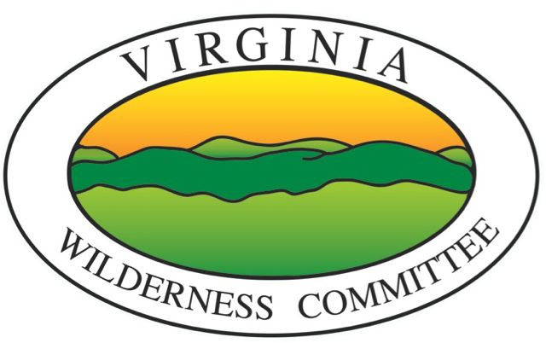
VIRGINIA WILDERNESS COMMITTEE
www.vawilderness.org
For Immediate Release, Nov 20 2014

Contact: Jeremy Boggs, P.O. Box 4586, Charlottesville, VA 22905
Phone: (434) 242-4707 email: jlboggslaw@gmail.com
Wilderness Conservation Group Applauds National Forest Plan
Charlottesville, VA After years of delay, the George Washington National Forest (GWNF) has released its final Land Management Plan, which will guide land use decisions for the next decade on 1.1 million acres of federal land in western Virginia.

“We applaud the U.S. Forest Service for its commitment to environmental protection,” said Jeremy Boggs, president of the Virginia Wilderness Committee (VWC), a grass roots conservation group. “The plan’s recommendations for 27,200 acres of Wilderness and 67,000 acres of National Scenic Area offer permanent protection for some of the most pristine, natural places left in Virginia. We are particularly excited to see the proposed Shenandoah Mountain National Scenic Area incorporated into the plan, and want to thank the Forest Service for working with our group and other forest stakeholders.”
Wilderness Areas and National Scenic Areas are legal designations on federally owned lands that confer high levels of permanent protection. Such areas must be defined in a bill passed by Congress. The VWC, founded in 1969, has supported past legislation that led to the designation of six Wildernesses and one National Scenic Area in the GWNF. Altogether, this acreage covers less than 5 percent of the GWNF, while the national average for Wilderness Areas in national forests is 18%.

Wilderness designation prohibits mining, gas drilling, and road building, but allows hunting, fishing, and hiking. "Wilderness Areas help provide the backbone of our rich hunting and fishing traditions,” said Peter Barlow, a hunter and U.S. Fish and Wildlife Service official.

Logging is also prohibited in Wilderness Areas. “Large undisturbed forest areas will help make our local ecosystems resilient as conditions change,” said Rick Webb, a senior scientist at UVA. “Plus they provide critical benefits such clean air and drinking water.”

Thousands of Shenandoah Valley residents drink water from streams coming out of recommended Wilderness Areas. Ultimately, millions of people live downstream of the many rivers that have headwaters in the GWNF.

National Scenic Area designation is less restrictive than Wilderness, and allows roads and other infrastructure. “We support keeping the existing public roads on Shenandoah Mountain open,” said VWC’s Boggs, “and the areas recommended for Wilderness designations don’t have any roads. They offer opportunities for solitude and connection with nature that other places can’t.”

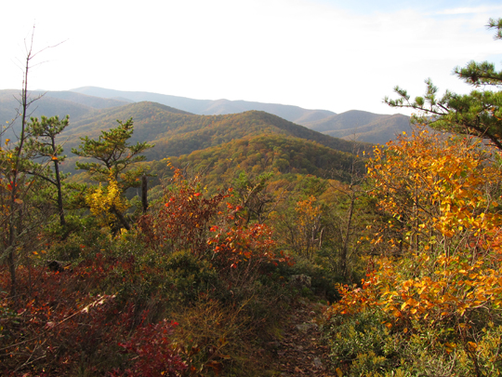

The Little River area on Shenandoah Mountain in the George Washington National Forest, recommended as a Wilderness Area in the new Forest plan. Photo by Malcolm Cameron.

