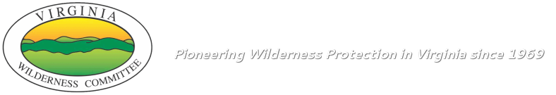

Press Release from the Virginia Wilderness Committee
For Immediate Release: July 8, 2019

Contact: Mark Miller, Executive Director, (540) 460-0593 or mmiller@vawilderness.org

VIRGINIA WILDERNESS COMMITTEE CELEBRATES 50TH ANNIVERSARY

Lexington, Virginia July 8, 2019 – The Virginia Wilderness Committee (VWC) is celebrating the 50th anniversary of its founding. In celebration of its achievements, VWC will be hosting an event on Saturday, August 3, at the Ivy Creek Natural Area to share with its members and other guests the milestones and challenges of the last 50 years, while looking forward to future opportunity.

Special guest speaker, Dr. Rupert Cutler, will share experiences stemming from his involvement in the protection of Wilderness areas across the United States as assistant executive director of The Wilderness Society and as the assistant secretary for Natural Resources and Environment of the U.S. Department of Agriculture.

In the wake of the passage of the Wilderness Act of 1964, and in anticipation of decisions being made about Eastern public lands, the Wilderness Society organized a series of local Virginia meetings to encourage grass-roots participation in the Wilderness movement. In Richmond on May 24-25, 1969 the Virginia Wilderness Committee was formally established.

From that time, VWC has been a driving force behind public land protection in Virginia. VWC has been behind the identification and legislative pushes of all 215,000 acres of designated Wilderness areas in Virginia and the three National Scenic Areas. VWC continues this tradition of activism today with ongoing efforts to establish new Wilderness Areas at Rich Hole and Rough Mountain, Beech Lick Knob, Shenandoah Mountain, and other areas.

The event will be held on Saturday, August 3, from 3-5 pm at the Ivy Creek Education Building, located at 1780 Earlysville Road, Charlottesville, VA 22901.

###

About the Virginia Wilderness Committee
The Virginia Wilderness Committee (VWC), a 501©3 non-profit, identifies and works to safeguard Virginia’s most outstanding remaining wild places. Securing Congressional protection for suitable wild lands is at the heart of our mission. Wilderness designation by Congress provides the highest form of protection available for our public lands and is the best way to leave a lasting wild legacy in Virginia. VWC also works to foster understanding and appreciation of Wilderness and promote enjoyment and stewardship of our last remaining wildlands.

